
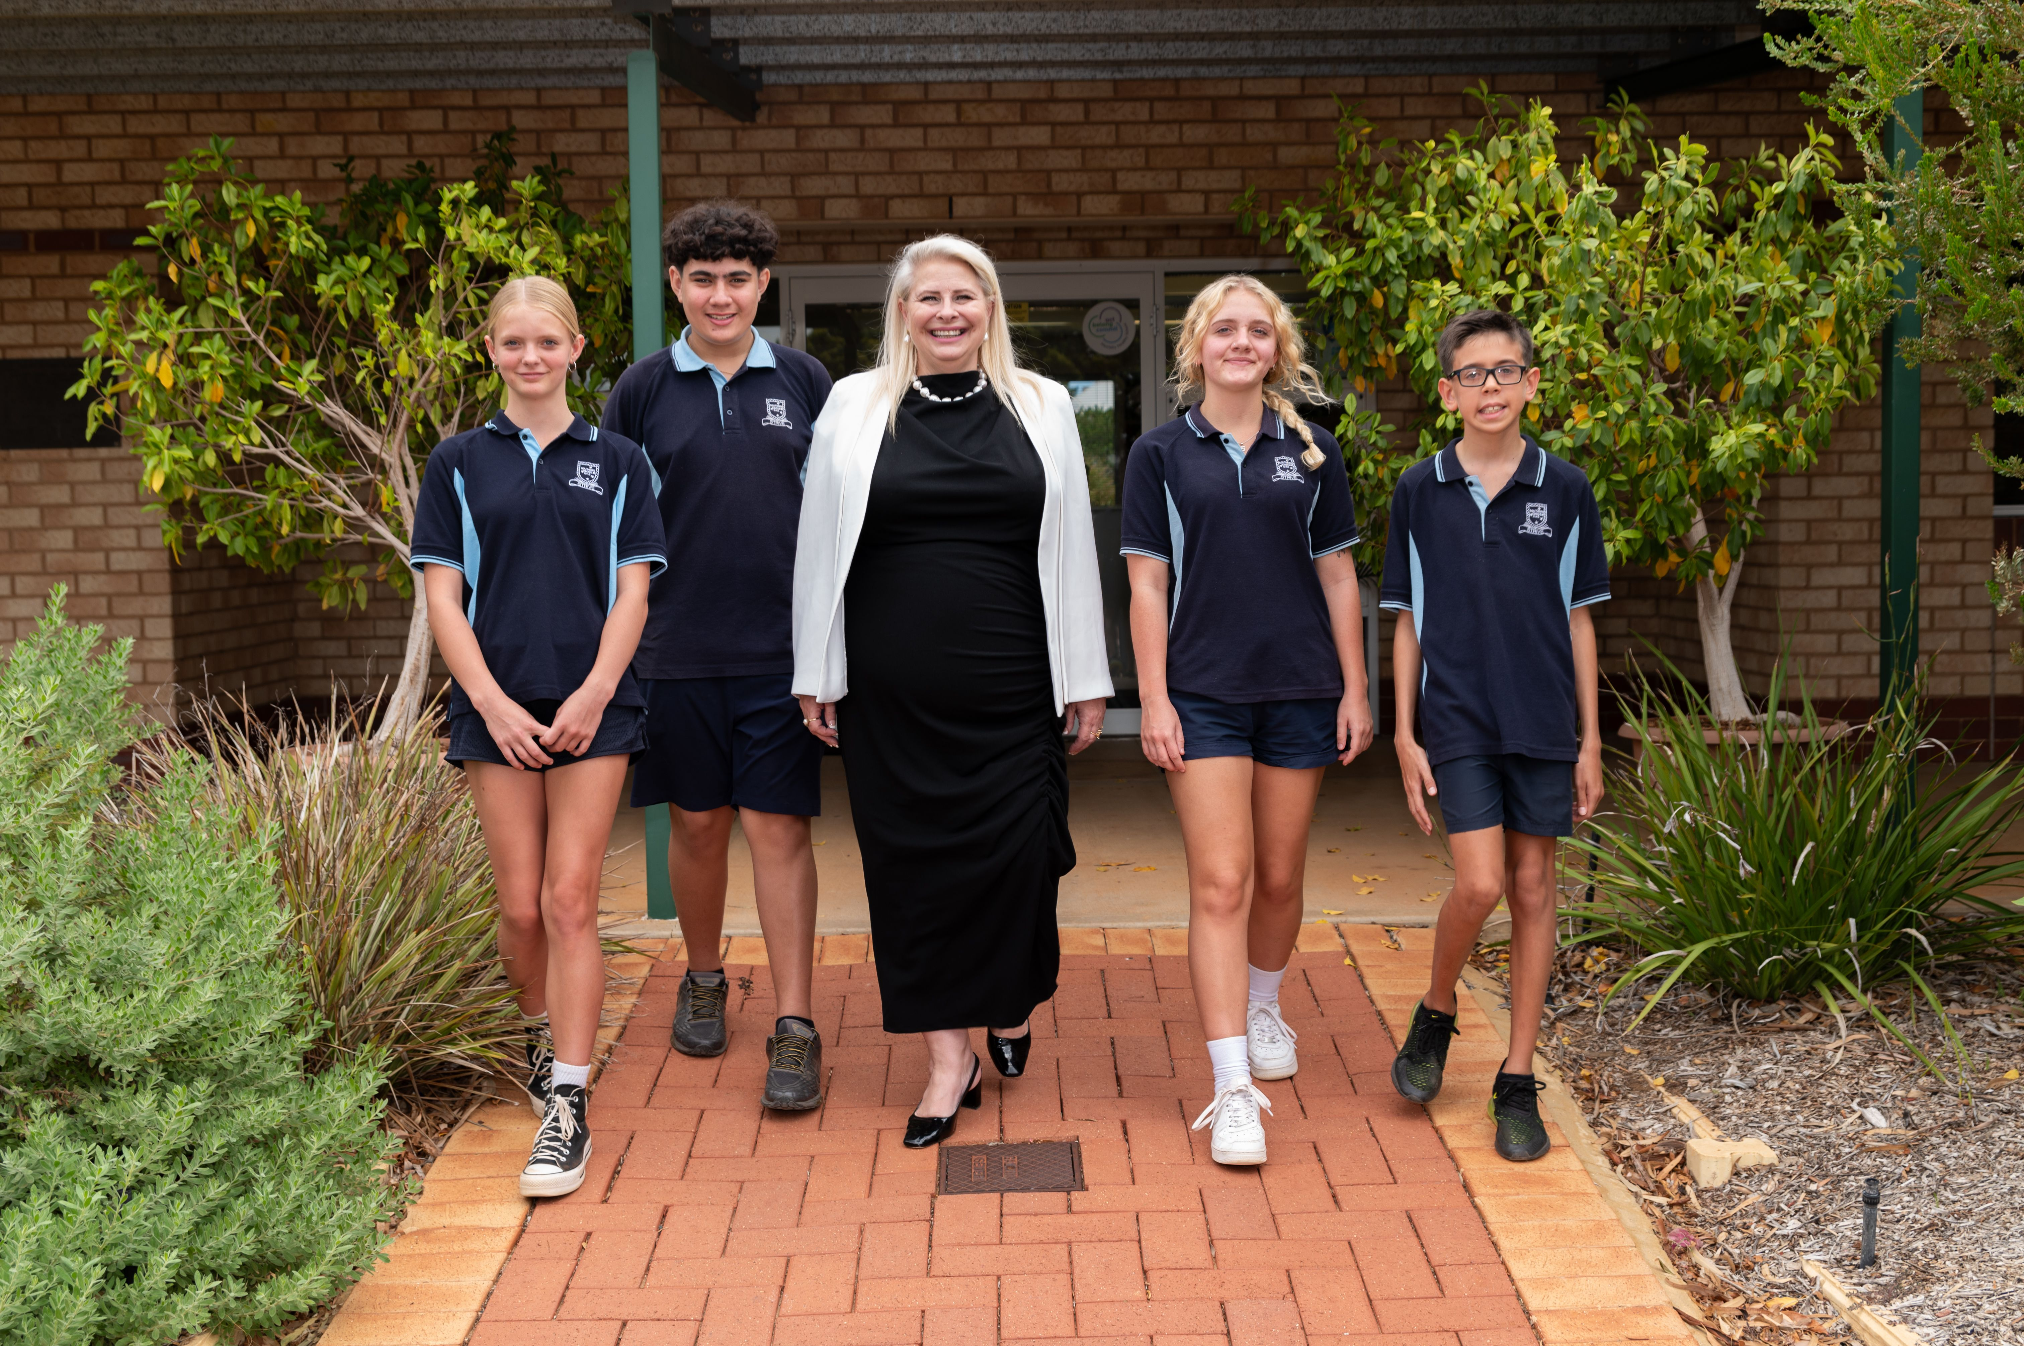Southern Cross District High School
Annual Report
2024

Contents

School Overview ........................................................................................................ 3 Principal’s Message ................................................................................................... 4 Relationships and Partnerships …............................................................................. 5 Learning Environment................................................................................................. 6 Leadership .................................................................................................................. 7 Use of resources ......................................................................................................... 8

Teacher Quality …………….......................................................................................... 8
Student Achievement and Progress ……………………………………………..…………… 9
Workforce Composition ……………………..…………………………………………………. 12
Teacher Satisfaction …………………………………………………………………………… 13
Business Plan Review ………………………………………………………………………….. 15
Finance …………………………………………………………………………………………….. 17
Glossary …………………………………………………………………………………………… 18

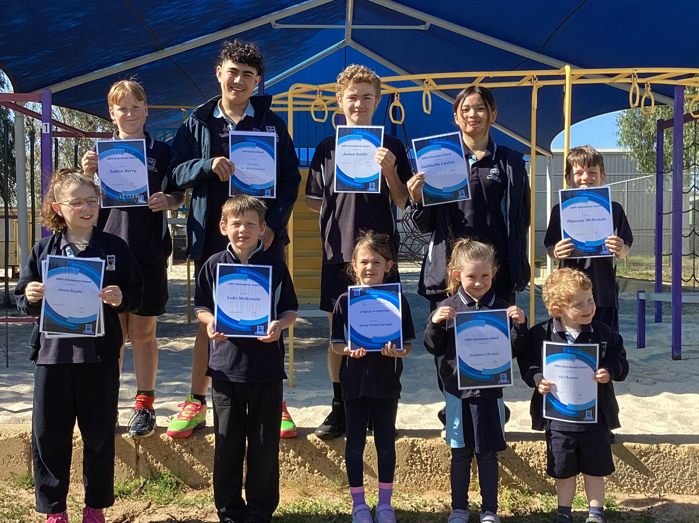

School Overview
Southern Cross District High School, located in the Eastern Wheatbelt, provides contemporary education for around 55 students from Kindergarten to Year 10. Our small student population enables us to offer a personalised learning environment, whilst also providing a breadth of curriculum, teacher expertise and resourcing. Foremost, our school aims to empower students with the values, skills and knowledge essential in becoming valued members of their local community and beyond.
Staff and students strive to achieve their personal best, though we understand success comes in different forms for each individual. We implement the Positive Behaviour Support Program and its central philosophy, that promoting positive behaviour and expectation creates the best learning environment and expect staff and students alike to reach for our Positive Behaviour Support 'Stars'.
Our highly motivated and caring staff provide quality learning opportunities for our students in a safe and supportive manner, with a strong emphasis on strengthening relationships. Specialised early childhood and primary teachers, together with support staff, deliver individualised, innovative and engaging programs. Our specialist secondary teachers provide a diverse curriculum so students positively transition to senior schooling and beyond.
Recognising that parents and the broader community play a vital role in supporting our initiatives, we have forged strong links with our local community. This includes the local mining and agriculture industry. We have formed partnerships with several families who have been in the district for generations, through partnerships with the local Shire, businesses, mining companies, sporting organisations and neighbouring schools. These partnerships are strengthened through our staff, many of whom play an active role in the broader community.
Southern Cross District High School provides a safe, happy and supportive learning environment.

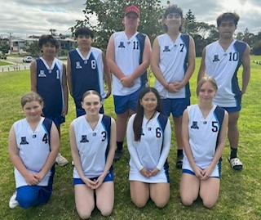

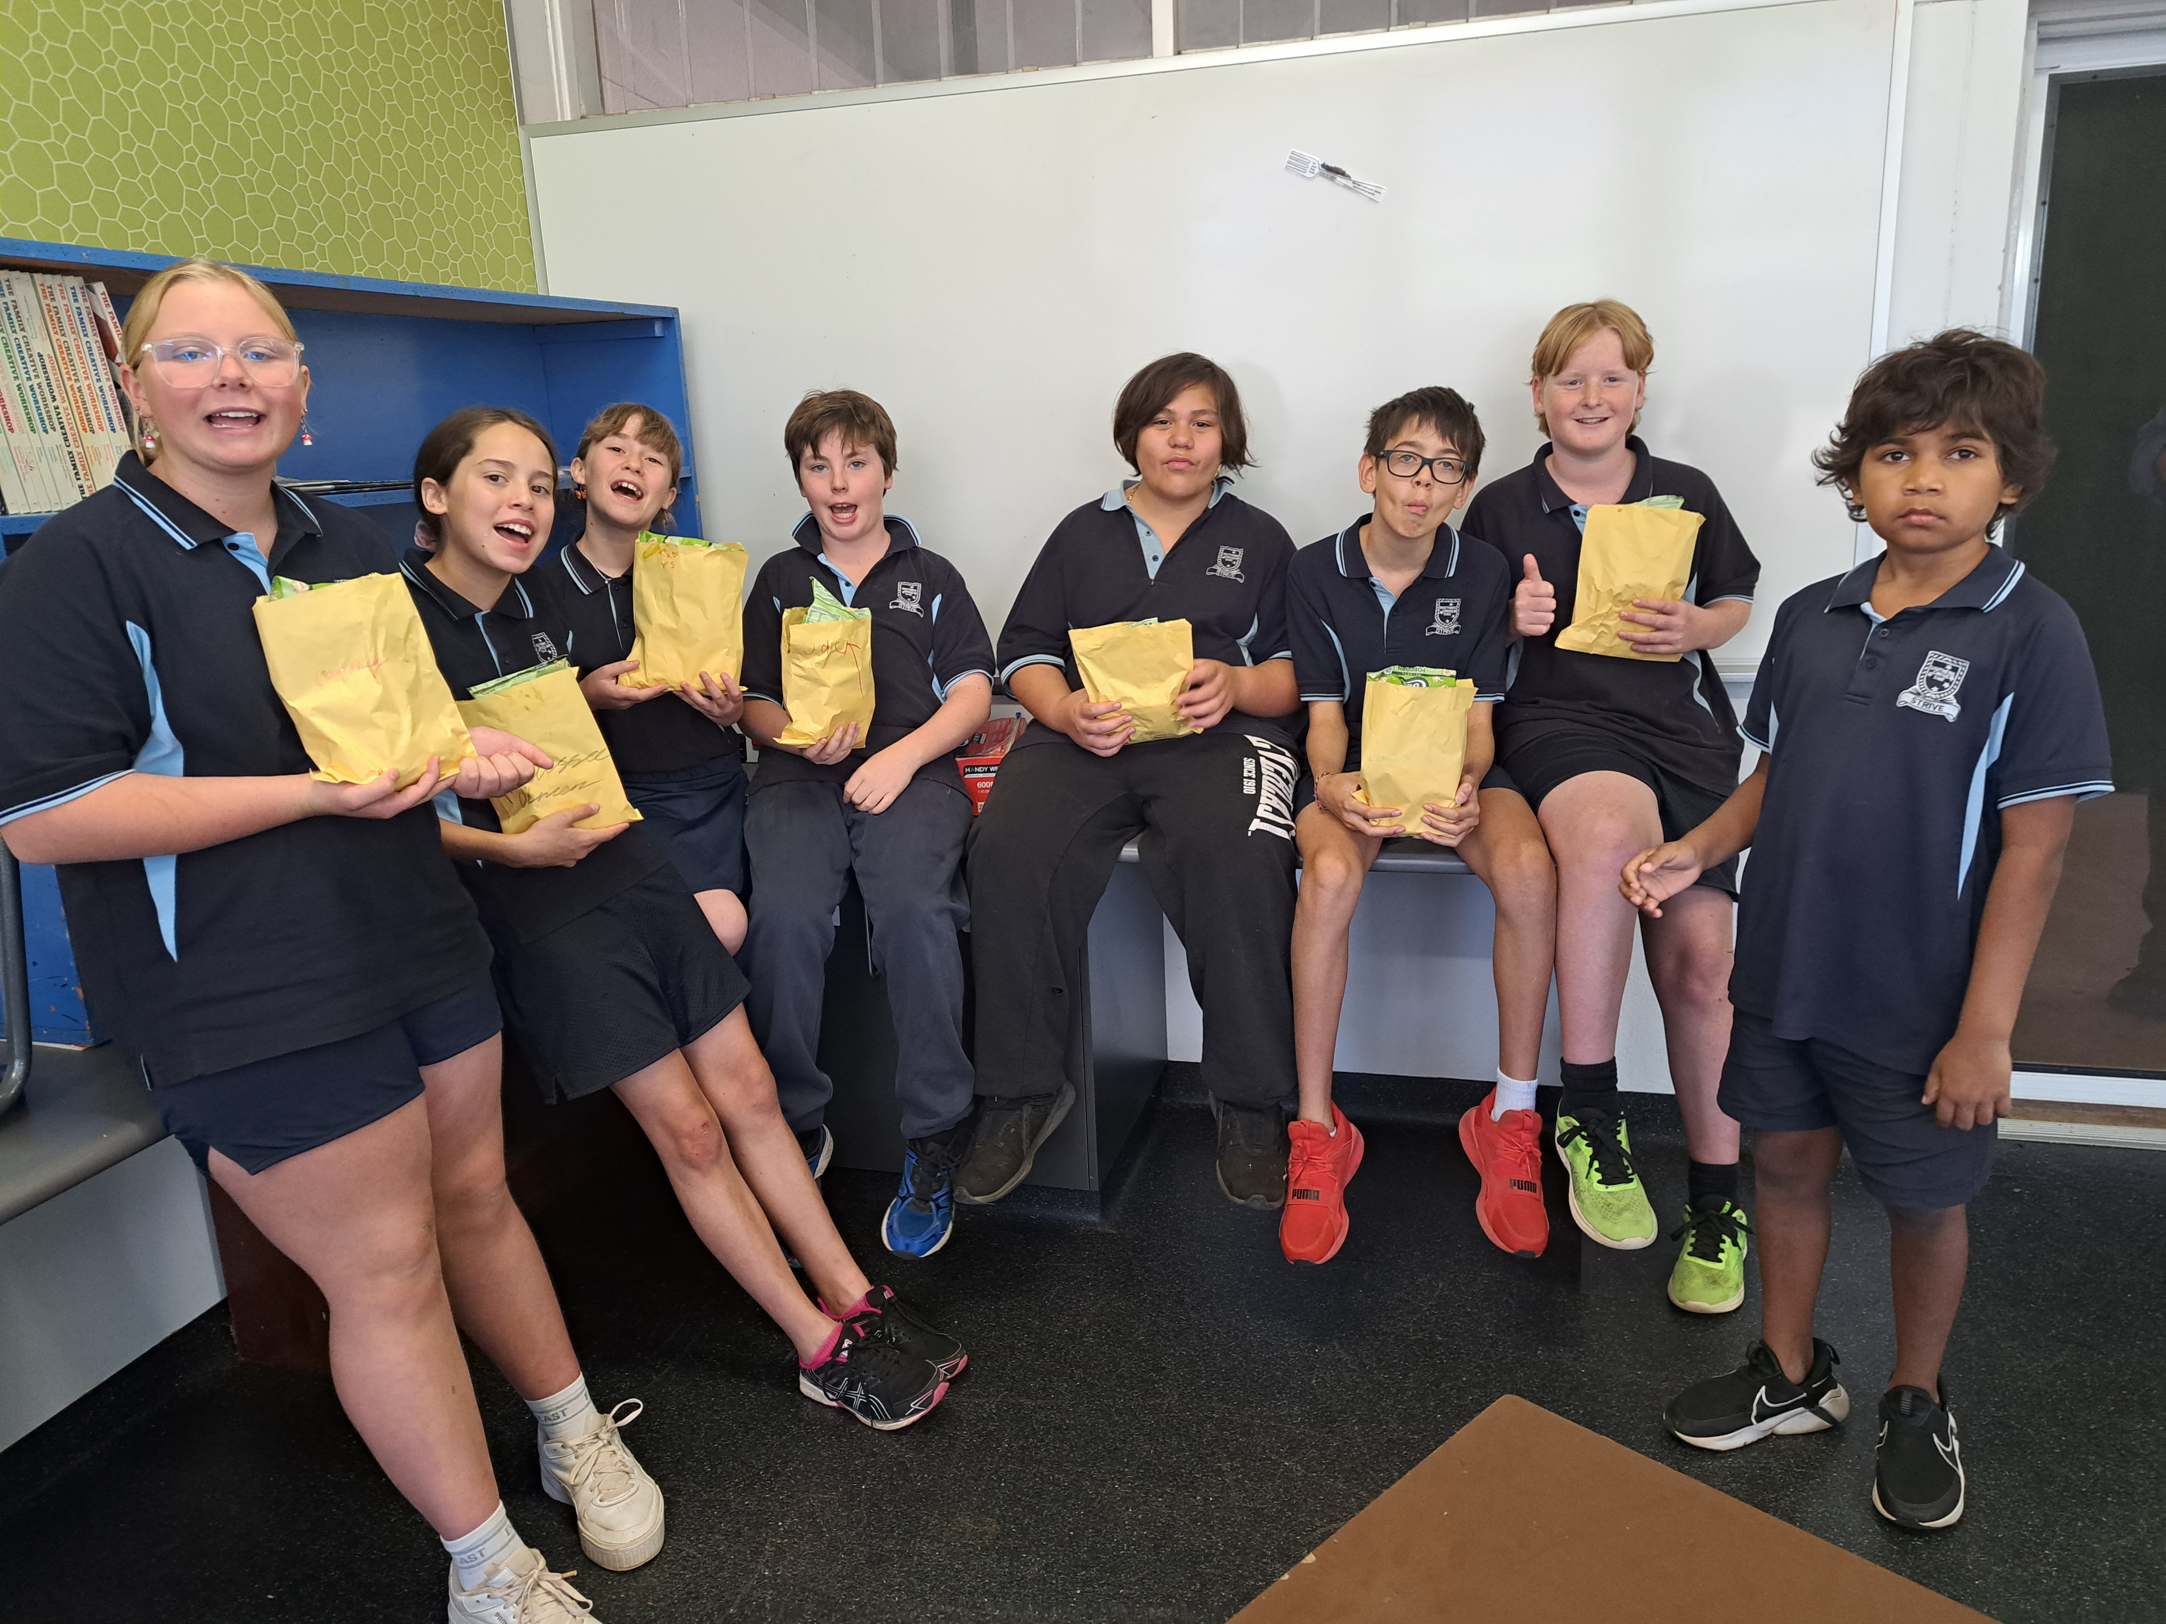

Principal’s Message

Reflecting on the past twelve months, I am particularly proud of the exceptional work that we continue to undertake in the delivery of quality education to our young people. We continue to take great strides forward in our commitment to provide every student with a pathway to a successful future, transitioning them from primary to middle school and then on to high or agricultural schools.

Throughout the year we have continued to focus on providing students with access to a high-quality learning environment, teachers, support staff and resources. This journey has been some three years in the making and in December 2023 the school received recognition for its work by achieving a three-year return for our Public School Review.

We have undertaken a three-year school improvement journey The Fogarty EDvance School Improvement Program focuses on building the capacity of the school team to make informed evidence-based decisions, strategically plan, and ultimately, improve student outcomes. This vision to improve the educational outcomes of children attending schools in regional communities, parallel’s the school’s vision of ensuring each student can reach for their own individual stars. Our implementation of explicit instruction and evidenced based programs will only highlight improved results in the future.

Southern Cross District High School is building its reputation for improved literacy and numeracy results, a disruption free learning environment and accommodating the needs of all our students. We continue to provide special days, which are celebrated across the year, including celebrating Attendance and providing Breakfast Club for our students three times per week.

Southern Cross District High School is opening its doors to the community and the community has been involved in our school, more than ever. We now have volunteers coming every day to read to our students, run Breakfast Club, have meet and greets, open Board Meetings; and this has resulted in improved communication between the community, school and families. Our assemblies have increased attendance, as we have reduced the number of assemblies, but promoted awards, such as Attendance, Mathematics, Literacy and Principal Awards. We have also introduced Certificates to the school for the first time and our students are being recognised in the community and local businesses are employing them to work. Our reputation is growing through our improvements.

The School Community were excited to present our new Business Plan for 2024-2027.

I have great pride in being the Principal of Southern Cross District High School. I commit to being an instructional leader, who always sees the bigger picture towards our vision. This means supporting staff for quality professional learning that aligns with our Fogarty Focus Areas. I support staff by building their capacity, so that we have distributed leadership that is sustainable.

I present the 2024 Annual Report.

LOUISE DAVIDSON
PRINCIPAL

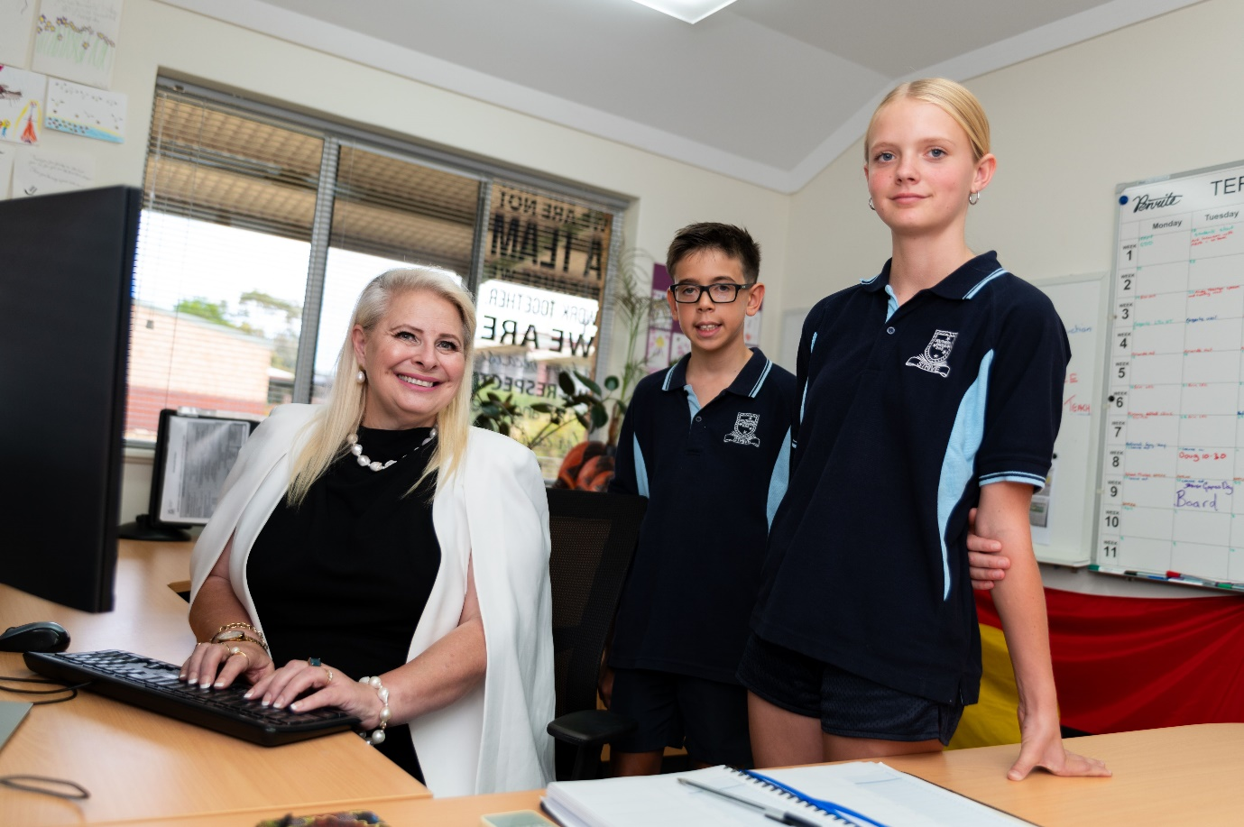

Student Numbers and Characteristics

RELATIONSHIPS & PARTNERSHIPS
Positive school climates, good relationships with communities
and strong parent support are powerful influences in Southern Cross District High School’s success.

Develop opportunities for Collaboration between staff | We have participated in many different forms of collaboration for our staff:  - Two staff members have received CMS Training with other schools.  - Five staff members have collaborated with other schools around Fogarty Edvance  - Four staff members have visited Narembeen District High School to view their Numeracy block.  - Staff have had joint DOTT, where available, to hold professional discussions.  - SDD’s allows for collaboration between staff in regards to data, physical, social and emotional and academic.  - Early Close Meetings have allowed staff to have constants such as behaviour, stars and discussions around curriculum.  - Some teachers have participated in a Wheatbelt SIDE Moderation Group
School Community satisfaction feedback is sought and acted on. | The School has held:  P and C Meetings,  Meet and Greets with Parents,  SEN Plan Meetings,  Assemblies,  Volunteers  Learning Journey  Here families converse with staff and their feedback is sought and acted upon.
The Board fulfils its role in supporting school governance. | The SCDHS Board plays an important role in contributing to good school governance so that school resources are used efficiently, and community expectations and the school’s priorities reflect the needs of students.  The functions of our board is covered by legislation and include both approval and advisory roles. Some of the matters the Board may make decisions on include: fees and charges and book lists.  The SCDHS Board makes these decisions with the principal and other relevant decision-makers who ensure the decisions adhere to legislative and policy requirements.
Community partnerships are sustainable. | We continue to be overawed by our Community, who support our students with donations, time and resources.

LEARNING ENVIRONMENT
s District High School strives to establish a safe, positive and supportive learning environment for students and staff.

Establish a social and emotional program for students. | We have implemented a social and emotional program called Friendly Schools. This is an evidence-based program to increase social and emotional wellbeing and reduce bullying.  The Health and Wellbeing of our students is very important. We have set up a Vulnerable Families Meeting, where the Shire, Drs surgery, hospital, schools and WAPOL meet and discuss how we can best support our students. We regularly provide information and resources for our families in our newsletter.  Southern Cross District High School regularly promotes special days that allow students to celebrate mental health days, such as: R U OK Day. Students also participate in free dress days, dress up days and crazy hair days.
Student attendance rates are monitored, analysed and acted upon to improve attendance. | The school’s Attendance Plan supports improvement in this key area. It is acknowledged that severe attendance issues remain a concern, especially at the middle school. These issues are complex and difficult to resolve.  The Attendance Plan outlines Targets and importantly focuses on Monitoring and Follow Up Procedures, Intervention Strategies, Recognition Strategies and Data Collection. Notably, the plan includes the strategy of building a range of options to re-engage students especially those with anxiety as anecdotally this is becoming more frequent with the non-attending students.  Currently we are sitting on 75% attendance. With the middle school having improved attendance compared to the primary school.
Students at educational risk are identified and supported in their learning in consultation with parents. | When supporting students at Educational Risk, The administration at SCDHS:  - Coordinates the School Psychologist referral process.  - Provides professional learning around SEN Planning and supports staff to utilise this for development and implementation of their Documented Plans.  - Coordinates twice-yearly Case Conferences for Disability Resourced students, ensuring all stakeholders are at these meetings.  - Coordinates Case Conferences for additional students to support their learning and progress.  - Seeks SSEN:BE and SSEN:D support for classroom teachers and Education Assistants and coordinate Visiting Teacher timetables.  - Supports timetable development for Education Assistants.  - Works closely with classroom teachers and Education Assistants to utilise explicit evidence-based instruction.
Develop plans to ensure the learning environment caters for diversity, inclusivity and is culturally responsive. | We have won a PALS Grant, to build a garden of self-reflection and healing and we will be looking for advice from our Aboriginal families for their support in this, as highlighted in our SCDHS Aboriginal Cultural Standards Framework.

LEADERSHIP
Southern Cross District High School leaders are concerned with
leadership practice and how it is exercised and transacted.

There is evidenced of distributed leadership within the school. | Southern Cross District High School has a high level of collaboration and consultation between the emerging leaders and staff to support the effectiveness of this structure. The school’s MCS also plays a key role in ensuring it is successful. Southern Cross District High School continues to establish an effective distributed leadership structure.  This structure consists of;  - Principal, Louise Davidson  - Primary Deputy Principal, Alison East  - Numeracy Coordiinator: Hope Tisdell  - Literacy Coordinator: Erin Kinson  - Student Leader: Hope Tisdell  - PBS Leader, Janine Dal Busco
Leaders provide instruction support for staff through observation and feedback | Formal Performance Management sessions were held with all staff, with follow up informal meetings at point of need.
Leaders participate in Fogarty Edvance. | We have commenced our three year Fogarty Edvance journey, where our strategic direction for our school is to ensure that every student succeeds, reaches for their own stars and, we would really like to move from below like schools in reading and numeracy. As a leadership team, we communicated the need for high expectations, explicit instruction and quality teaching. We need to do this by having connected practises and low variance across the school, so students can move from class to class and year to year with an expectation of how they will be taught.

USE OF RESOURCES
Southern Cross District High School manages resources in a targeted manner,
maximising the learning outcomes for all students.

Implement resources to allow for the Fogarty Edvance transformation program. | The Finance Committee together with the Fogarty Edvance Leadership Team are confident that the Budget and Resource allocations support the school’s vision and budgetary requirements.
Develop succession plans for administration. | A Workforce Management Plan is written each year and provided to the School Board for their notation and to the teaching staff.  To ensure sustainability within the school, we are currently training a Deputy and a Level 2 Ministerial Officer.
Ensure compliance with the Funding Agreement for Schools. | The Finance Committee meets twice a term to support the Principal, Deputy Principal and Manager of Corporate Services to allocate resources accordingly and monitor expenditure. From this, Finance is then shared with the School Board to ensure compliance with the Funding Agreement for Schools.

TEACHING QUALITY
Southern Cross District High School will invest significantly in creating and
sustaining the conditions under which quality teaching can prosper.

There is evidence of a simultaneous, uninterrupted literacy block at the start of each day. | The Literacy Committee has been established to review quality teaching practises, implement targets and develop literacy blocks each morning. Students move from Year level to Year level to attend Litereacy lessons that are directly related to their level of ability.
Provide professional learning via the Quality Teaching Strategy Partnerships Initiative and Fogarty to build staff capability. that aligns with school wide and departmental foci. | All staff members have attended professional learning at Narembeen District High School, who is our mentor school for the QT Strategy. Five staff members have received PL directly as a member of the Fogarty Edvance team.
Quality, research-based programs are implemented across the school, with intervention, support, and differentiation a key focus on improving student outcomes for all students. | SCDHS employs many different programs that are evidenced based to support student learning, such as IniaLit, Spellex and Friendly Schools.
STUDENT ACHIEVEMENT AND PROGRESS
Southern Cross District High School communicate clearly about
student progress, where teachers can build parent confidence in
their judgements about standards of achievement.

A clear assessment schedule has been developed where data is analysed, reviewed and acted upon. | At the beginning of each year staff review and develop an assessment schedule where data is then collated and staff meet to analyse this data to develop targets for the following year to improv eon student outcomes.
Teachers use a variety of different methods of assessment for individual tracking of student achievement. | Staff use a variety of different assessments from observation to quantitative and qualitative assessments, then use this as forms of collaboration and moderation.
Leaders support students by developing protocols around testing. | Currently the Administration team are running NAPLAN and OLNA to ensure fidelity of the testing.
Show an improvement of NAPLAN results from year to year to align with like schools. | NUMERACY  In Year 5, 7 and 9 we achieved slightly better than like schools, however, in Year 3 we performed lower than like schools in Numeracy.  READING  In Years 5 and 7 we achieved better than like schools, in Year 3 and Year 9 we performed lower than like schools in Reading.  WRITING  In Years 5 we strongly against like schools, in Years 7 and Year 9 we performed at level with like schools and in Year 3, we performed a lot lower than like schools in Reading.  SPELLING  In Years 5 and 7 we achieved leve to that of like schools, in Year 3 and Year 9 we performed lower than like schools in Spelling.  GRAMMAR AND PUNCTUATION  In all Years, we performed lower than like schools in Grammar and Punctuation.

Workforce composition
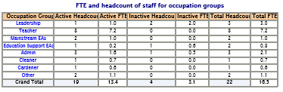
Comments:
Southern Cross DHS’s workforce is based on a blend of community people, and those who apply to work with us from a variety of other locations. The school has experienced teachers who drive the teaching and learning schedule of the school. A Deputy Principal has been appointed until 2026, as the substantive Deputy Principal is on parental leave.

In 2024, SCDHS was fully staffed with a variety of contract and permanent teachers. Flying Squad teachers were called upon when teachers took long service leave or extended sick leave.

Attracting and retaining teachers has historically been a challenge, largely due to our location and housing accessibility. The Attraction and Retention payment has assisted with staffing for 2024, however, for 2025 this payment has reduced by over 50% and this will affect the transiency and stability of staff.

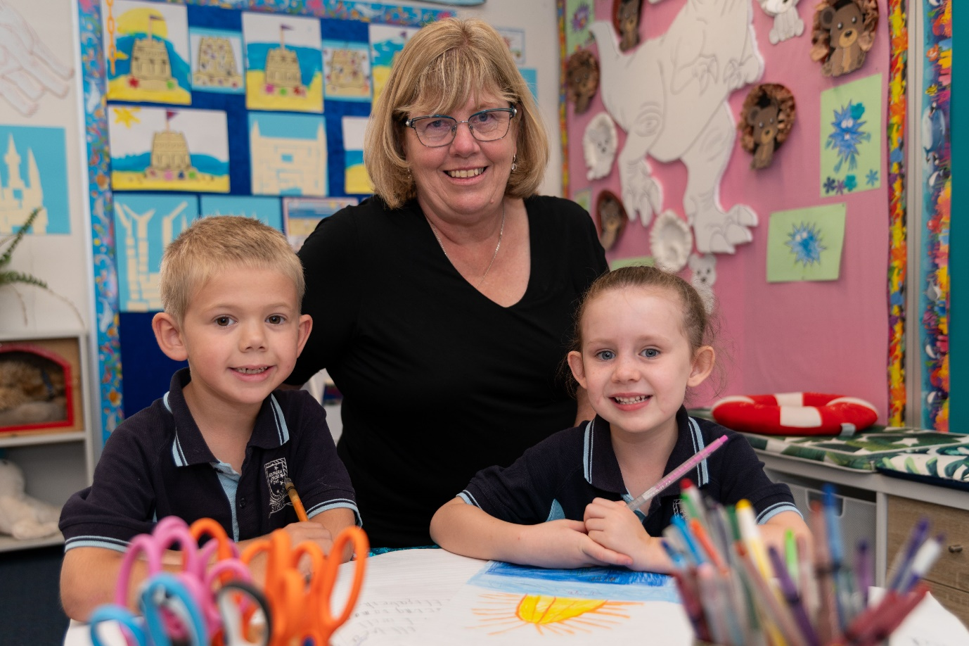

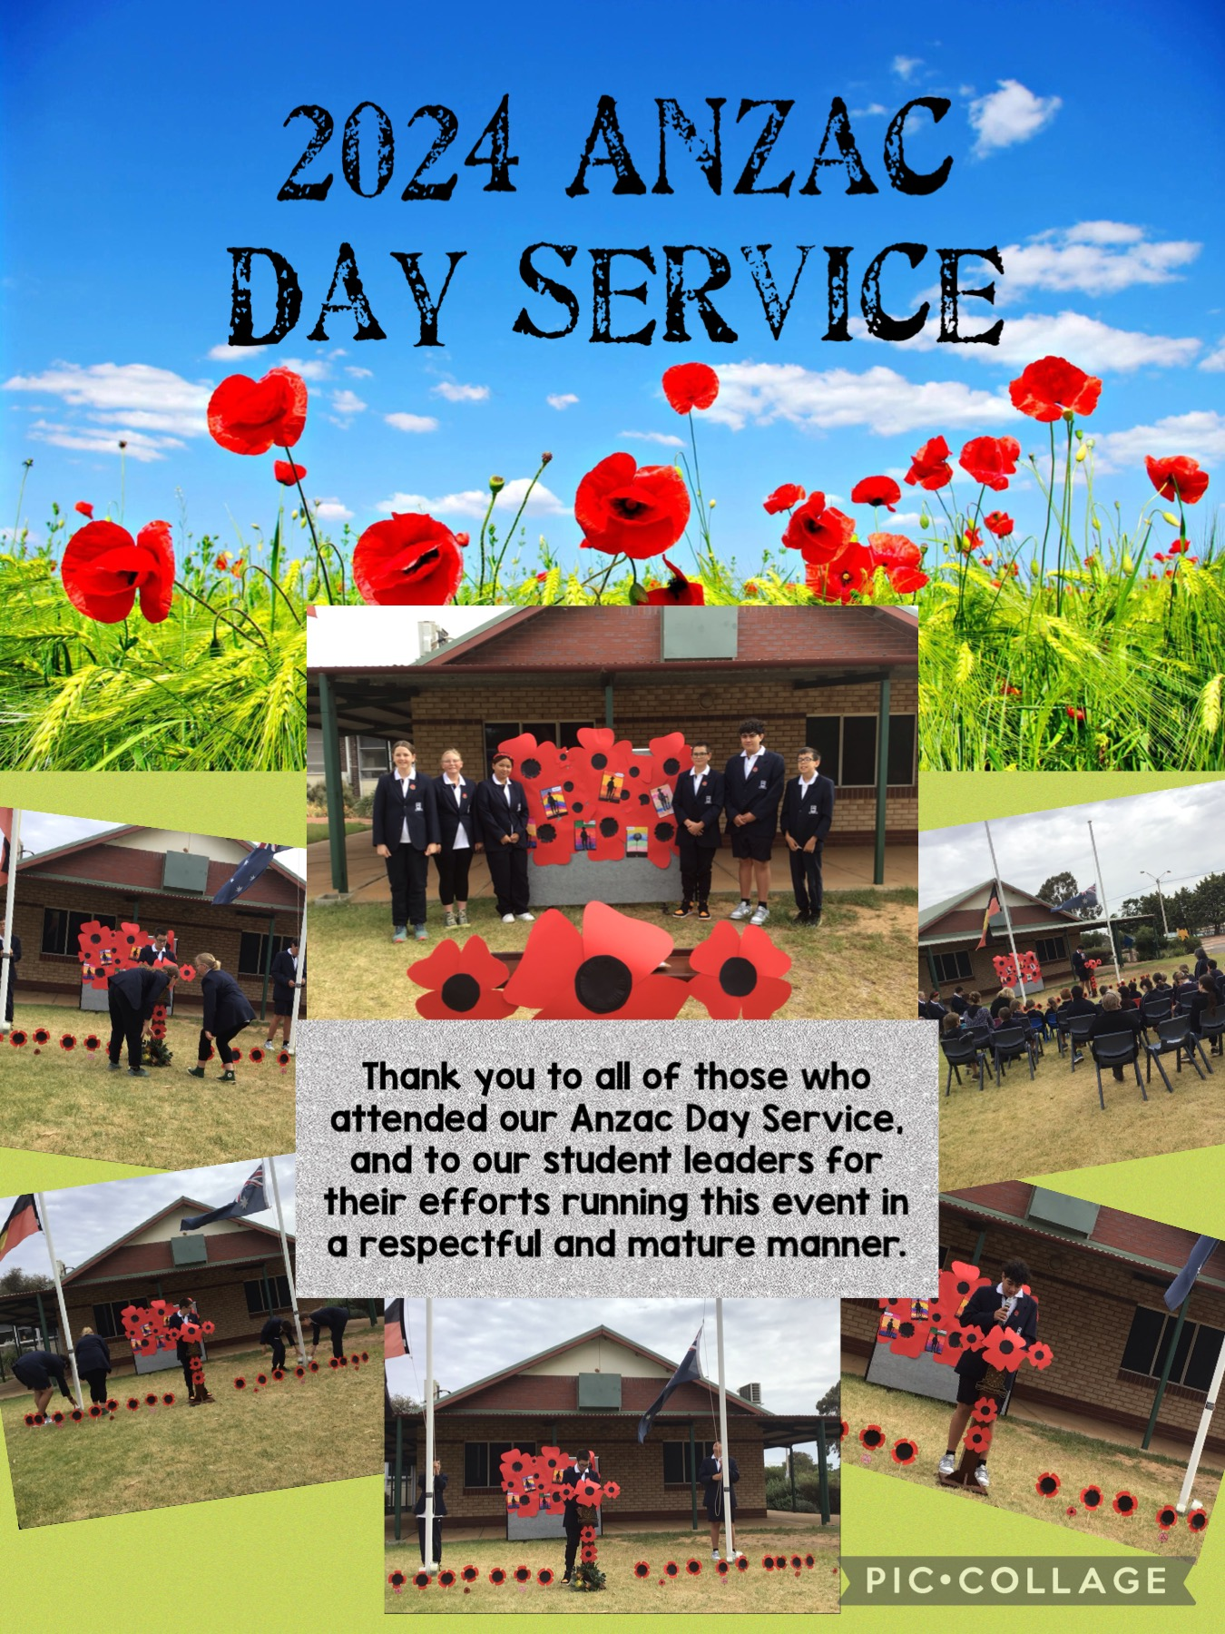

TEACHER SATISFACTION WITH THE SCHOOL
2024 saw the staff undertake a Culture Audit, designed to access our school culture and to evaluate areas of strength and weakness to work together to strength the ‘culture’ at Southern Cross District High School.

Professional Collaboration | Score
1. Teachers and staff discuss instructional strategies and curriculum issues. | 93%
2. Teachers and staff are involved in the decision-making process with regard to materials and resources. | 82%
3. The planning and organisational time allotted to teachers and staff is used to plan as collective teams rather than as separate individuals. | 86%
4. Staff exhibit a collective ownership of the students, their outcomes and school facilities. | 96%
5. Staff leadership is supported and valued at our school. | 96%
6. School administration communication with staff is timely, clear and concise. | 92%
Comment:
- Sometimes consultation needs to occur with a variety of staff before decisions are made.
- Still early
- Great staff
Collegiality | Score
1. Our school reflects a true “sense” of community. | 96%
2. Our school supports and appreciates the sharing of new ideas by staff members. | 96%
3. The school admin team is approachable and accessible to staff when they require support and advice. | 99%
4. People work here because they enjoy and choose to be here. | 96%
5. The well-being of staff is a priority at Southern Cross District High School | 97%
Comment:
- Lots of laughs
Self-Determination/Efficacy | Score
1. When something is not working in our school staff predict and prevent rather than react and repair. | 80%
2. School staff members are interdependent and value each other. | 91%
3. Staff are given leadership opportunities through the delegation of responsibilities. | 95%
4. Members of our school staff trust each other. | 92%
5. Members of our school staff trust the school leadership. | 96%
Comment:
- Very happy here thank you.
- Leadership at SCDHS is approachable and trustworthy
Professional Learning |  | Score
- Staff had the opportunity to present ideas to each other. |  | 9292%
- Staff had opportunity to work in PLC’s together. |  | 9999%
- Staff had opportunity to have time in their classrooms. |  | 9999%
- The morning topics were relevant both with new topics and reminders. |  | 9699%
- The staff’s professional and personal wellbeing was catered for. |  | 9999%
Comment:
- Thanks for the morning tea and lunch
- Keep it up people, well done
Even better if:
- We received a timetable for the day before Monday morning

These are fantastic results and we are very pleased, however, we will always strive to improve on these.

BUSINESS PLAN REVIEW

Business Plan Foci |  |  | How are we going? | How do we know? | Where to next?
Improvement Areas Identified | RELATIONSHIPS AND PARTNERSHIPS | Develop opportunities for Collaboration between staff. |  | PLC’S Literacy and Numeracy to make plans for each term  Staff offered opportunity to undertake professional learning together  Use of morning fitness has allowed us to have more common dott | Ensure staff have common literacy and numeracy block and then timetabled dott to discuss this
 |  | School Community satisfaction feedback is sought and acted on. |  | Parent contact made during open days, such as Meet and Greet and Learning Journeys. . | Carried out when NSSO is sought Formal responses in 2025
 |  | The Board fulfils its role in supporting school governance. |  | Board has roles and responsibilities and continues to support school governance with policies and procedures | Continue to work closely with school board and board chair
 |  | Community partnerships are sustainable. |  | STEM Day, Literacy Day, NAIDOC Day carried out with St Jo’s and MRPS, Clontarf Basketball Game, Country Week | Continue to invite schools in the future, currently have MRPS coming for a SCITECH visit
 | LEARNING ENVIRONMENT | Establish a social and emotional program for students. |  | Schools helps build critical social and emotional skills, create positive, safe and supportive learning environments, and significantly reduce bullying in both primary and secondary schools. | Continue to build on Friendly Schools using SEW Data to support
 |  | Student attendance rates are monitored, analysed and acted upon to improve attendance. |  | Attendance is monitored daily. | Align attendance policy with DoE attendance Policy  Continue to send out attendance letters and share information in newsletters
 |  | Students at educational risk are identified and supported in their learning in consultation with parents. |  | We have initiated the Lits to improve literacy | Continue upskilling EAs to help run the Lits in the classroom
 |  | Develop plans to ensure the learning environment caters for diversity, inclusivity and is culturally responsive. |  | NAIDOC Day, Harmony Day | Continue to build these into the future working with other schools
 | LEADERSHIP | There is evidenced of distributed leadership within the school. |  | Distributed leadership with  PLC Coordinators  Leadership Coordinator  PBS  CMS Coordinator | Continue to offer distributed leadership
 |  | Leaders provide instruction support for staff through observation and feedback. |  | Principal needs Deputy time to assist with this | Employ deputy and have a roster up of who is being observed when
 |  | Leaders participate in Fogarty Edvance. |  | Louise, Erin, Deputy and Janine have attended as part of the Fogarty leadership team. | Opening this up to other staff members to attend, such as Raylene
 | USEOF RESOURCES | Implement resources to allow for the Fogarty Edvance transformation program. |  | Implementation of roles and responsibilities  Induction files
 |  | Develop succession plans for administration. |  | We have developed a deputy file, induction file for staff, | Working on Principal and front office staff plans
 |  | Ensure compliance with the Funding Agreement for Schools |  | This is done as part of our processes every year | Continue this for 2025
 | TEACHING QUALITY | There is evidence of a simultaneous, uninterrupted literacy block at the start of each day. |  | Have a block set up for both Literacy and Numeracy | Continue this for 2025
 |  | Provide professional learning via the Quality Teaching Strategy Partnerships Initiative and Fogarty to build staff capability. That aligns with school wide and departmental foci. |  | Six staff members attending these | Open this up to more staff
 |  | Quality, research-based programs are implemented across the school, with intervention, support, and differentiation a key focus on improving student outcomes for all students. |  | Lits, Friendly Schools, Spellex | Visiting mentor school Narembeen to look at Prime for a whole school maths program
 | STUDENT ACHIEVEMENT AND PROGRESS | A clear assessment schedule has been developed where data is analysed, reviewed and acted upon. |  | Whole school assessment schedule organised | Remind staff on weekly memos of what is due when
 |  | Teachers use a variety of different methods of assessment for individual tracking of student achievement. |  | Common data bank for all staff | Continue to monitor data bank
 |  | Leaders support students by developing protocols around testing. |  | As per the guidelines of the PSR  Principal has taken NAPLAN and OLNA testing | Continue with this in the future

2023 FINANCE

ONE LINE BUDGET - Dec 2024 ( Verified Nov Cash)
 | Current Budget ($) | Actual YTD ($)
Carry Forward (Cash): | 129,394 | 129,394
Carry Forward (Salary): | 779,857 | 779,857
INCOME
Student-Centred Funding (including Transfers & Adjustments): | 1,845,786 | 1,845,786
Locally Raised Funds: | 24,061 | 24,062
Total Funds: | 2,779,097 | 2,779,098
EXPENDITURE
Salaries: | 1,395,236 | 1,395,236
Goods and Services (Cash): | 357,513 | 271,609
Total Expenditure: | 1,752,749 | 1,666,846
VARIANCE: | 1,026,348 | 1,112,253
INCOME - Dec 2024 ( Verified Nov Cash)
 | Current Budget ($) | Actual YTD ($)
Carry Forward (Cash) | 129,394 | 129,394
Carry Forward (Salary) | 779,857 | 779,857
STUDENT-CENTRED FUNDING
Per Student | 589,309 | 589,309
School and Student Characteristics | 1,091,286 | 1,091,286
Disability Adjustments | 0 | 0
Targeted Initiatives | 136,689 | 136,689
Operational Response Allocation | 28,502 | 28,502
Total Funds: | 1,845,786 | 1,845,786
TRANSFERS AND ADJUSTMENTS
Regional Allocation | 0 | 0
School Transfers – Salary | (183,146) | (183,146)
School Transfers - Cash | 183,146 | 183,146
Department Adjustments | 0 | 0
Total Funds: | 0 | 0
LOCALLY RAISED FUNDS (REVENUE)
Voluntary Contributions | 830 | 830
Charges and Fees | 2,145 | 2,145
Fees from Facilities Hire | 0 | 0
Fundraising/Donations/Sponsorships | 9,575 | 9,575
Commonwealth Govt Revenues | 320 | 320
Other State Govt/Local Govt Revenues | 2,200 | 2,200
Revenue from CO, Regional Office and Other schools | 311 | 311
Other Revenues | 8,680 | 8,680
Transfer from Reserve or DGR | 0 | 0
Residential Accommodation | 0 | 0
Farm Revenue (Ag and Farm Schools only) | 0 | 0
Camp School Fees (Camp Schools only) | 0 | 0
Total Funds: | 24,061 | 24,061
TOTAL | 2,779,098 | 2,779,098
EXPENDITURE - Dec 2024 ( Verified Nov Cash)
 | Current Budget ($) | Actual YTD ($)
SALARIES
Appointed Staff | 1,313,241 | 1,313,241
New Appointments | 0 | 0
Casual Payments | 79,196 | 79,196
Other Salary Expenditure | 2,799 | 2,799
Total Funds: | 1,395,236 | 1,395,236
GOODS AND SERVICES (CASH EXPENDITURE)
Administration | 11,500 | 6,823
Lease Payments | 0 | 0
Utilities, Facilities and Maintenance | 168,671 | 147,488
Buildings, Property and Equipment | 21,500 | 28,503
Curriculum and Student Services | 122,091 | 65,656
Professional Development | 33,500 | 22,885
Transfer to Reserve | 0 | 0
Other Expenditure | 0 | 4
Payment to CO, Regional Office and Other schools | 251 | 251
Residential Operations | 0 | 0
Residential Boarding Fees to CO (Ag Colleges only) | 0 | 0
Farm Operations (Ag and Farm Schools only) | 0 | 0
Farm Revenue to CO (Ag and Farm Schools only) | 0 | 0
Camp School Fees to CO (Camp Schools only) | 0 | 0
Total Funds: | 357,513 | 271,610
TOTAL | 1,752,749 | 1,666,846

GLOSSARY

